LOW CODE
EXPERIMENT-1
COMPARATIVE STUDY: LOW CODE vs TRADITIONAL DEVELOPMENT
NAME: AR KRISHNA REG No.: 240701274

Aim: To study and understand the traditional software development approach and the low-code development approach, and to perform a comparative analysis between the two methodologies.

Introduction to Traditional Approach:-
- Traditional software development refers to the conventional method of building applications by writing source code manually, line by line, using programming languages such as Java, C++, Python, or JavaScript.
- It typically follows a structured lifecycle (like the Waterfall or Agile SDLC models) involving requirement gathering, design, coding, testing, deployment, and maintenance.
- This approach demands strong programming expertise, offers complete control over application logic and architecture, and is best suited for complex, highly customized, or performance-critical systems. However, it is time-consuming and requires a dedicated team of skilled developers.

Introduction to Low Code:-
- Low-code development is a software development approach that enables users to build applications with minimal hand-written code, using visual interfaces, drag-and-drop components, pre-built templates, and configuration over manual coding.
- Platforms like OutSystems, Mendix, Microsoft Power Apps, and Appian allow both professional developers and "citizen developers" (users with little coding background) to design workflows, UI, and logic visually.
- This drastically reduces development time and cost, and is well suited for rapid prototyping, internal business tools, and applications with straightforward logic — though it may offer less flexibility for highly specialized requirements

Diagram for stages in Traditional Approach:-

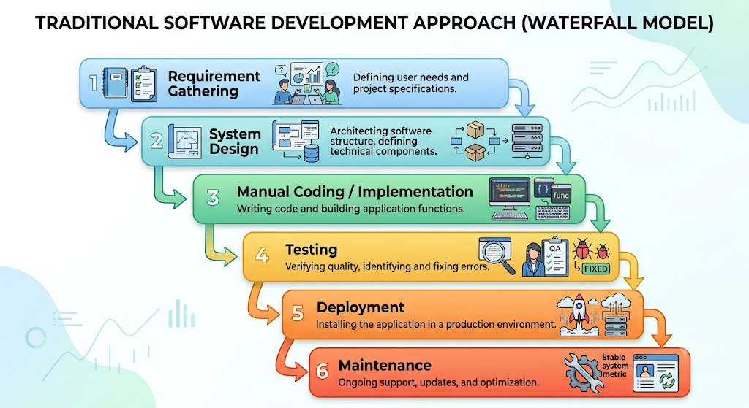

Diagram for stages in Low Code approach:-
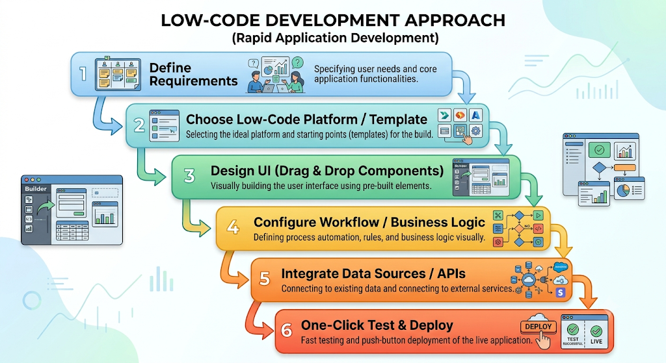

Comparative Analysis (Traditional vs Low Code):-

Parameter | Low Code Approach | Traditional Approach
Development time | Shorter (days to weeks) | Longer (weeks to months)
Coding skill required | Low to moderate (citizen developers can build) | High (expert programmers)
Customization | Limited by platform capabilities | Very high, full control
Cost | Lower (less manual effort) | Higher (more developer hours)
Flexibility | Less flexible for complex/custom logic | Highly flexible for complex logic
Maintenance | Easier via visual updates | Manual, code-level changes
Tools used | Visual builders, drag-drop platforms | IDEs, compilers, manual frameworks
Scalability | Scalable but platform-dependent | Highly scalable with proper architecture
Best suited for | Rapid prototyping, internal/business apps | Complex, mission-critical systems
Error debugging | Simplified but platform-restricted debugging | Manual, code-level debugging

Result: Thus, the traditional approach and the low-code approach to software development were studied, and a comparative analysis between the two was successfully performed and documented.

